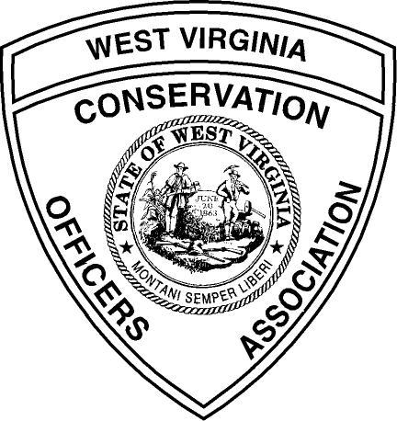WEST VIRGINIA CONSERVATION OFFICERS ASSOCIATION
Associate Membership Application

Individual Membership $25.00/ Year

Benefits: One year of quarterly newsletters, WVCOA Bumper Sticker (“Century of
Pride”) key chain and window decal. Other benefits are being discussed.

Corporate / Club Membership $100.00 / Year

Benefits: One year of quarterly newsletters for three officials, company name and logo listed in newsletters for year, 3 gift certificates for one item redeemable at our display booths.

Name:______________________________________________________

Address:____________________________________________________

City:___________________ State:__________________Zip:__________

E-mail_______________________ Phone:_________________________

Mail check or money order to WVCOA, Rt. 2 Box 303, Parsons, WV 26287

